# MIS 275 - Lab 5

You will need to complete this lab by using SQL Server Management Studio. Use your textbook, in class activity and lecture as resources for help in completing the lab. Once you have completed the assignment then upload it to Blackboard. Save your document with the following naming convention:

* Course_Lab Number_First Initial Last Name (Example: MIS275_Lab5_LStewart.docx)

My Guitar Shop Exercise 2

In these activities, you’ll use SQL Server Management Studio to enter SQL statements and run them against the MyGuitarShop database. In addition to providing screen prints, create a SQL script file that contains your SQL statements for the 7 exercises below. Once you’ve completed this lab, zip this Word document with your answers and your script file and upload the zipped file to the designated link in Blackboard.

1. Write a SELECT statement that joins the Categories table to the Products table and returns these columns: CategoryName, ProductName, ListPrice.

Sort the result set by CategoryName and then by ProductName in ascending order.

Paste a screen print of the SQL statement and the resulting data set below.

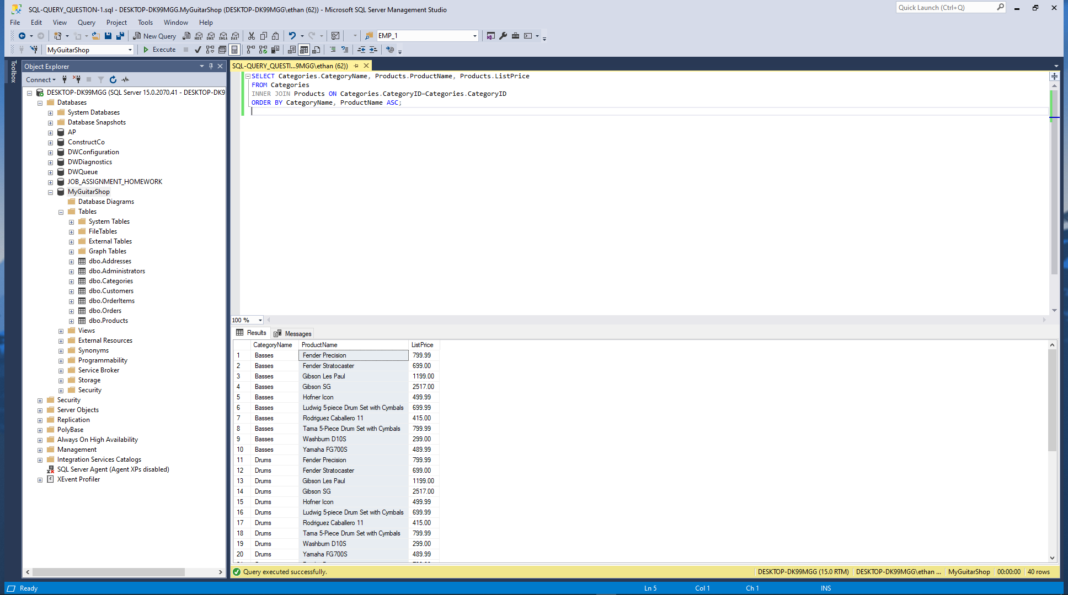

1. Write a SELECT statement that joins the Customers table to the Addresses table and returns these columns: FirstName, LastName, Line1, City, State, ZipCode.

Return one row for each address for the customer with an email address of [allan.sherwood@yahoo.com](mailto:allan.sherwood@yahoo.com).

Paste a screen print of the SQL statement and the resulting data set below.

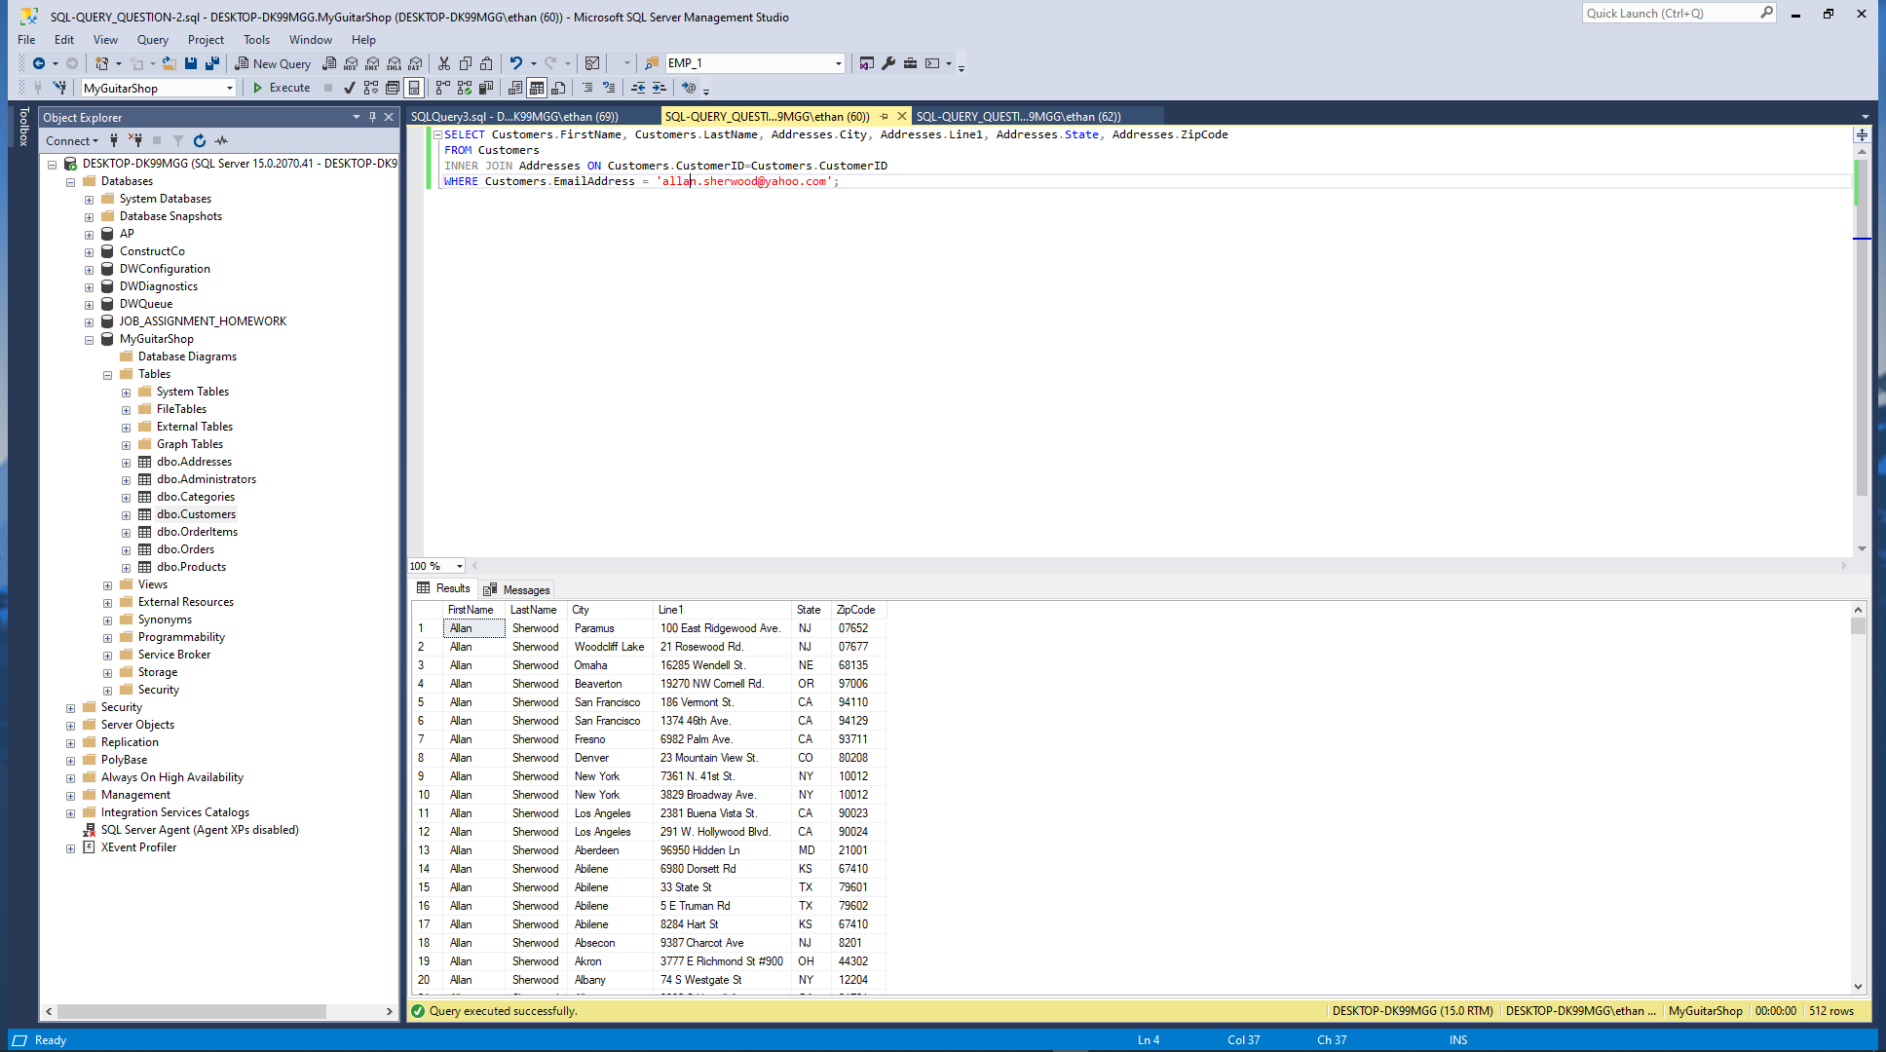

1. Write a SELECT statement that joins the Customers table to the Addresses table and returns these columns: FirstName, LastName, Line1, City, State, ZipCode.

Return one row for each customer, but only return addresses that are the shipping address for a customer.

Paste a screen print of the SQL statement and the resulting data set below.

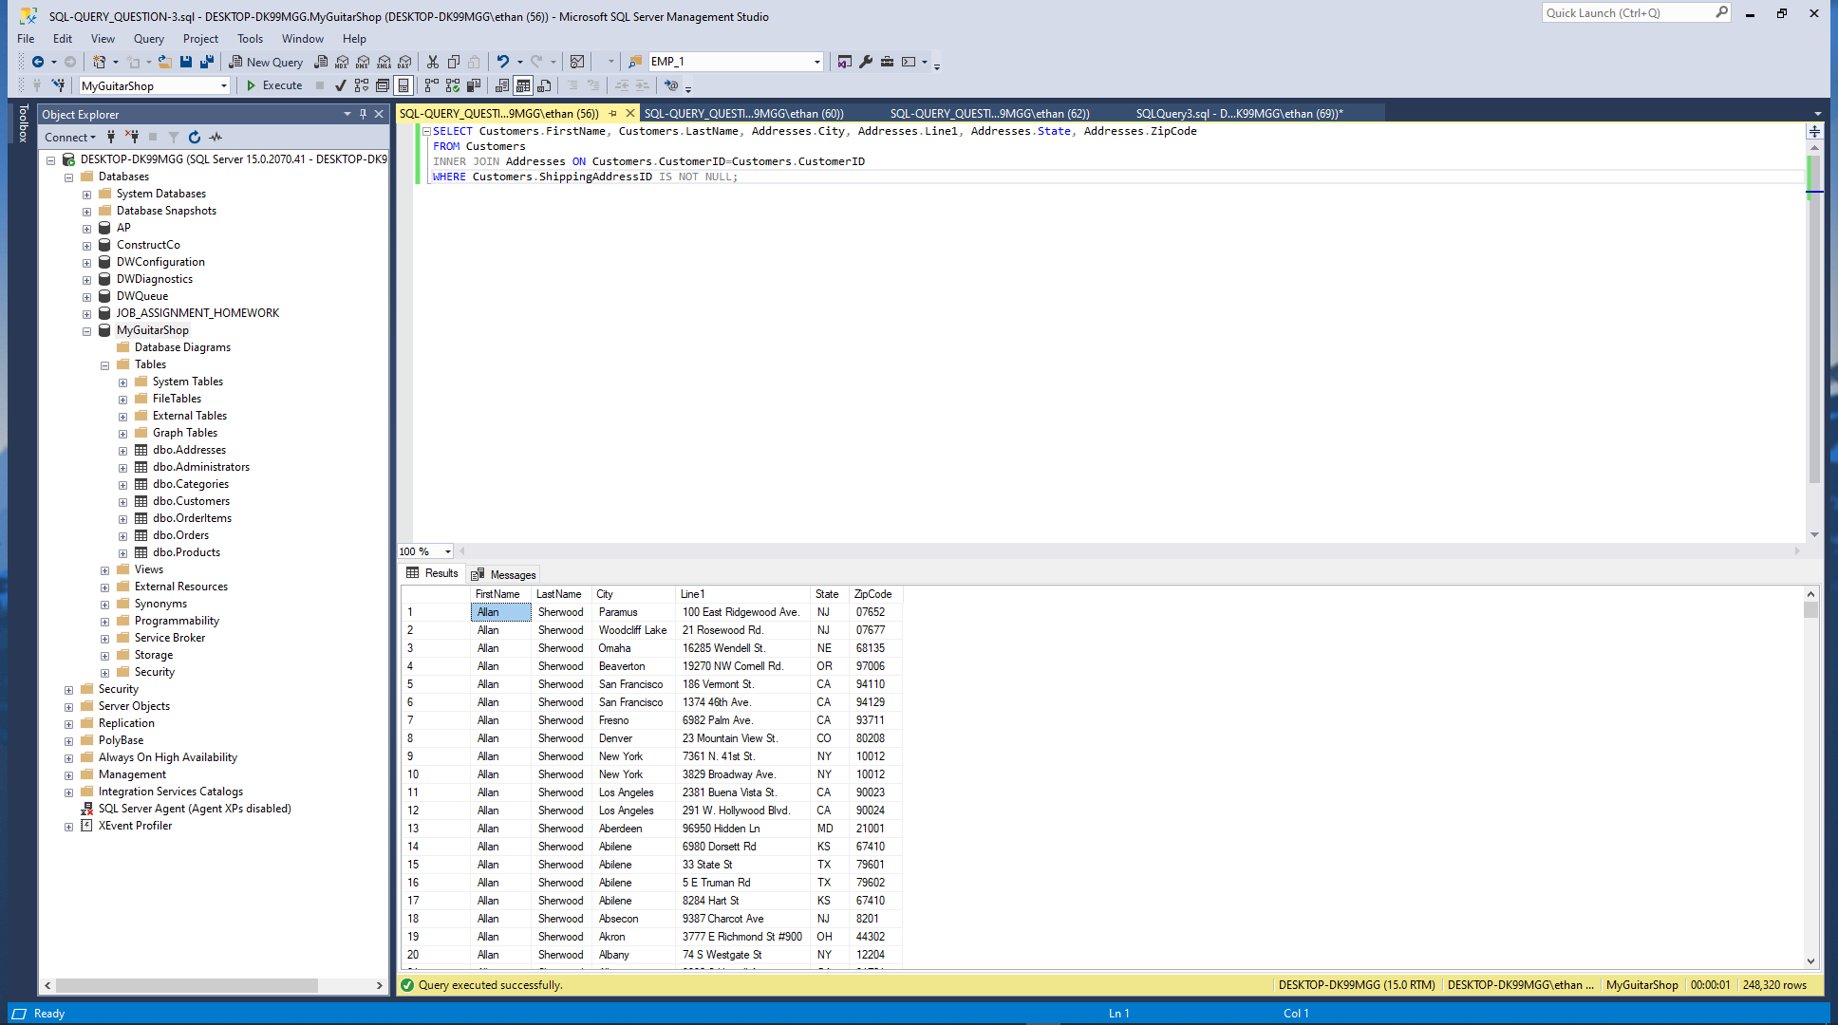

1. Write a SELECT statement that joins the Customers, Orders, OrderItems, and Products tables. This statement should return these columns: LastName, FirstName, OrderDate, ProductName, ItemPrice, DiscountAmount, and Quantity.

Use aliases for the tables.

Sort the final result set by LastName, OrderDate, and ProductName.

Paste a screen print of the SQL statement and the resulting data set below.

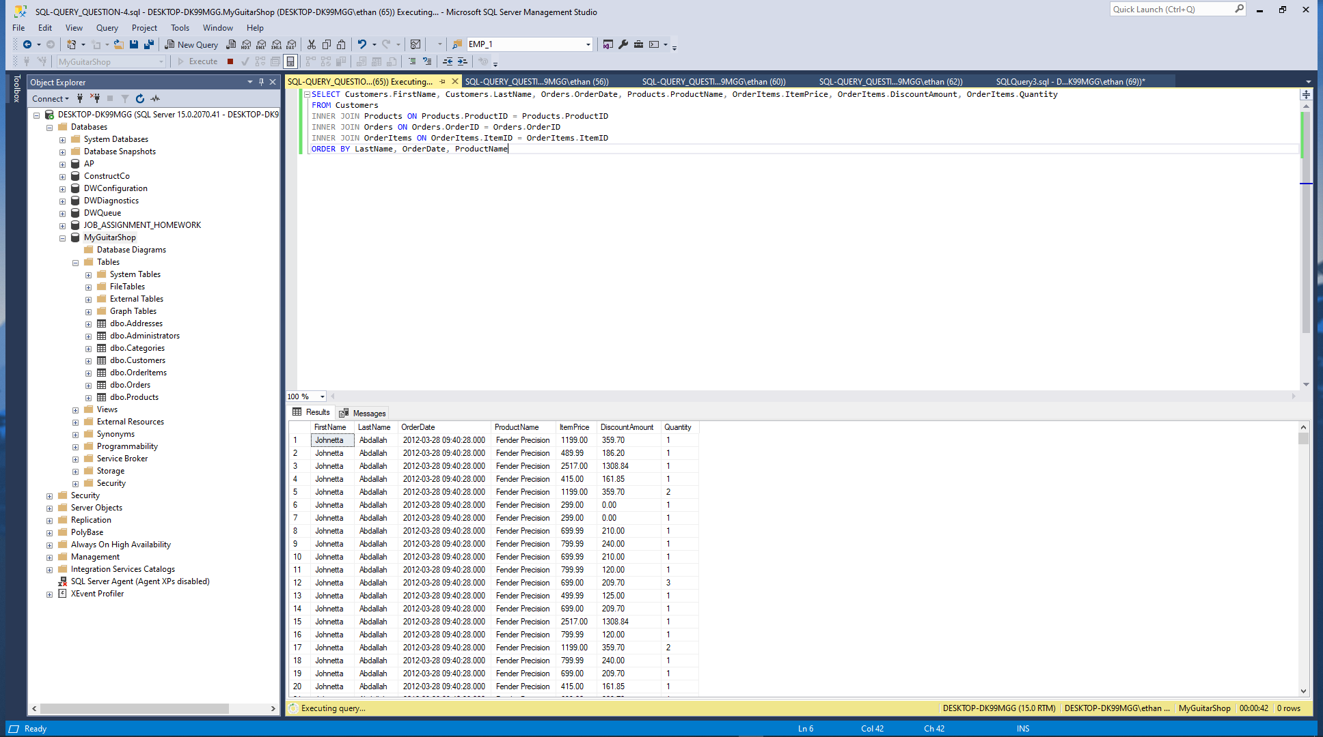

1. Write a SELECT statement that returns the ProductName and ListPrice columns from the Products table.

Return one row for each product that has the same list price as another product. *Hint: Use a self-join to check that the ProductID columns aren’t equal but the ListPrice column is equal.*

Sort the result set by ProductName.

Paste a screen print of the SQL statement and the resulting data set below.

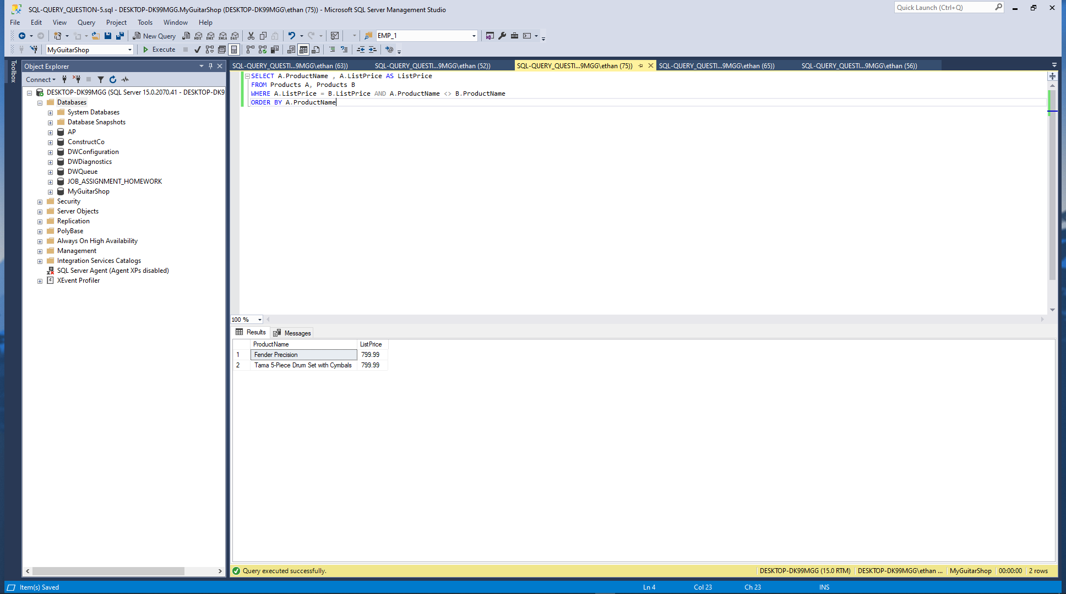

1. Write a SELECT statement that returns these two columns:

CategoryName The CategoryName column from the Categories table

ProductID The ProductID column from the Products table

Return one row for each category that has never been used. *Hint: Use an outer join and only return rows where the ProductID column contains a null value.*

Paste a screen print of the SQL statement and the resulting data set below.

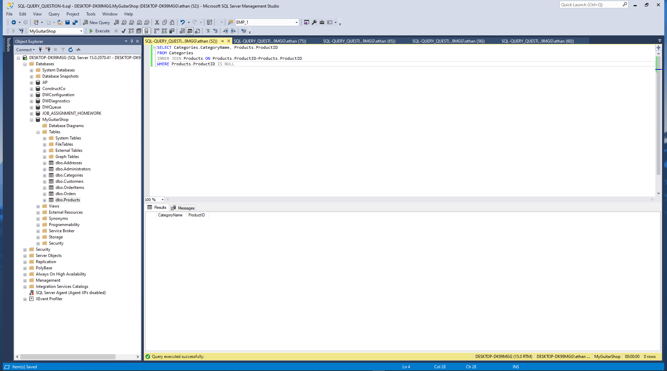

1. Use the UNION operator to generate a result set consisting of three columns from the Orders table:

ShipStatus A calculated column that contains a value of SHIPPED or NOT SHIPPED

OrderID The OrderID column

OrderDate The OrderDate column

If the order has a value in the ShipDate column, the ShipStatus column should contain a value of SHIPPED. Otherwise, it should contain a value of NOT SHIPPED.

Sort the final result set by OrderDate.

Paste a screen print of the SQL statement and the resulting data set below.

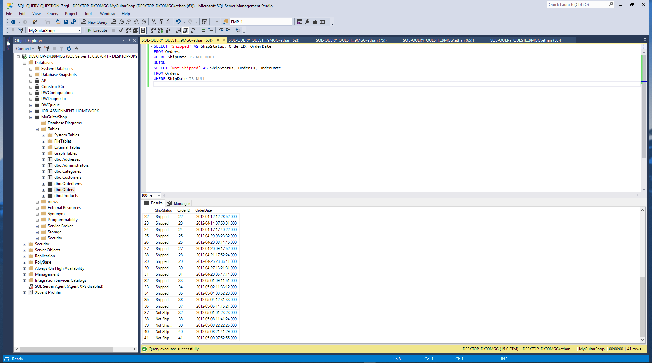

Complete Chapter 7 Problems 13, 18, 20, 21(Cengage Pg. 309-310)

For these problems, you’ll enter and run your SQL statements. In addition to providing screen prints, create a SQL script file that contains your SQL statements. Once you’ve completed this lab, zip this Word document with your answers and your script file and upload the zipped file to the designated link in Blackboard.

For these exercises number and answer below. Use red font when answering your question.

Number each problem and paste a screen print of the SQL statement and the resulting data set.

13. 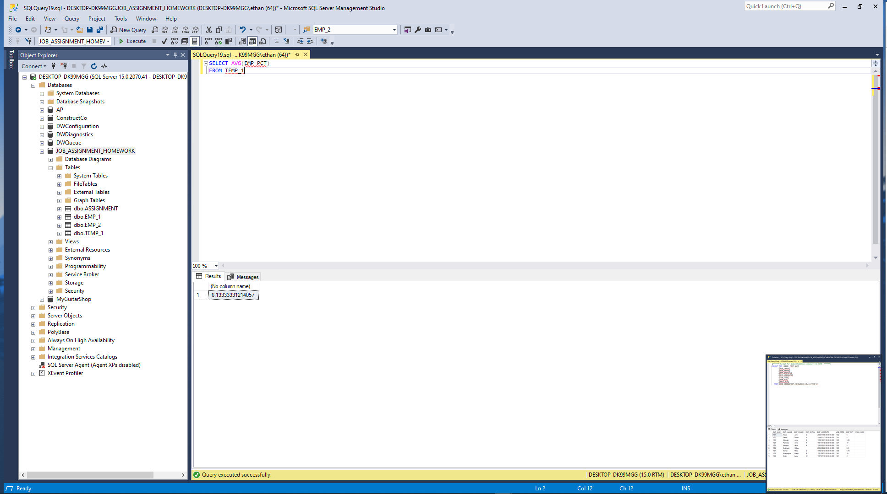

18. 

20. 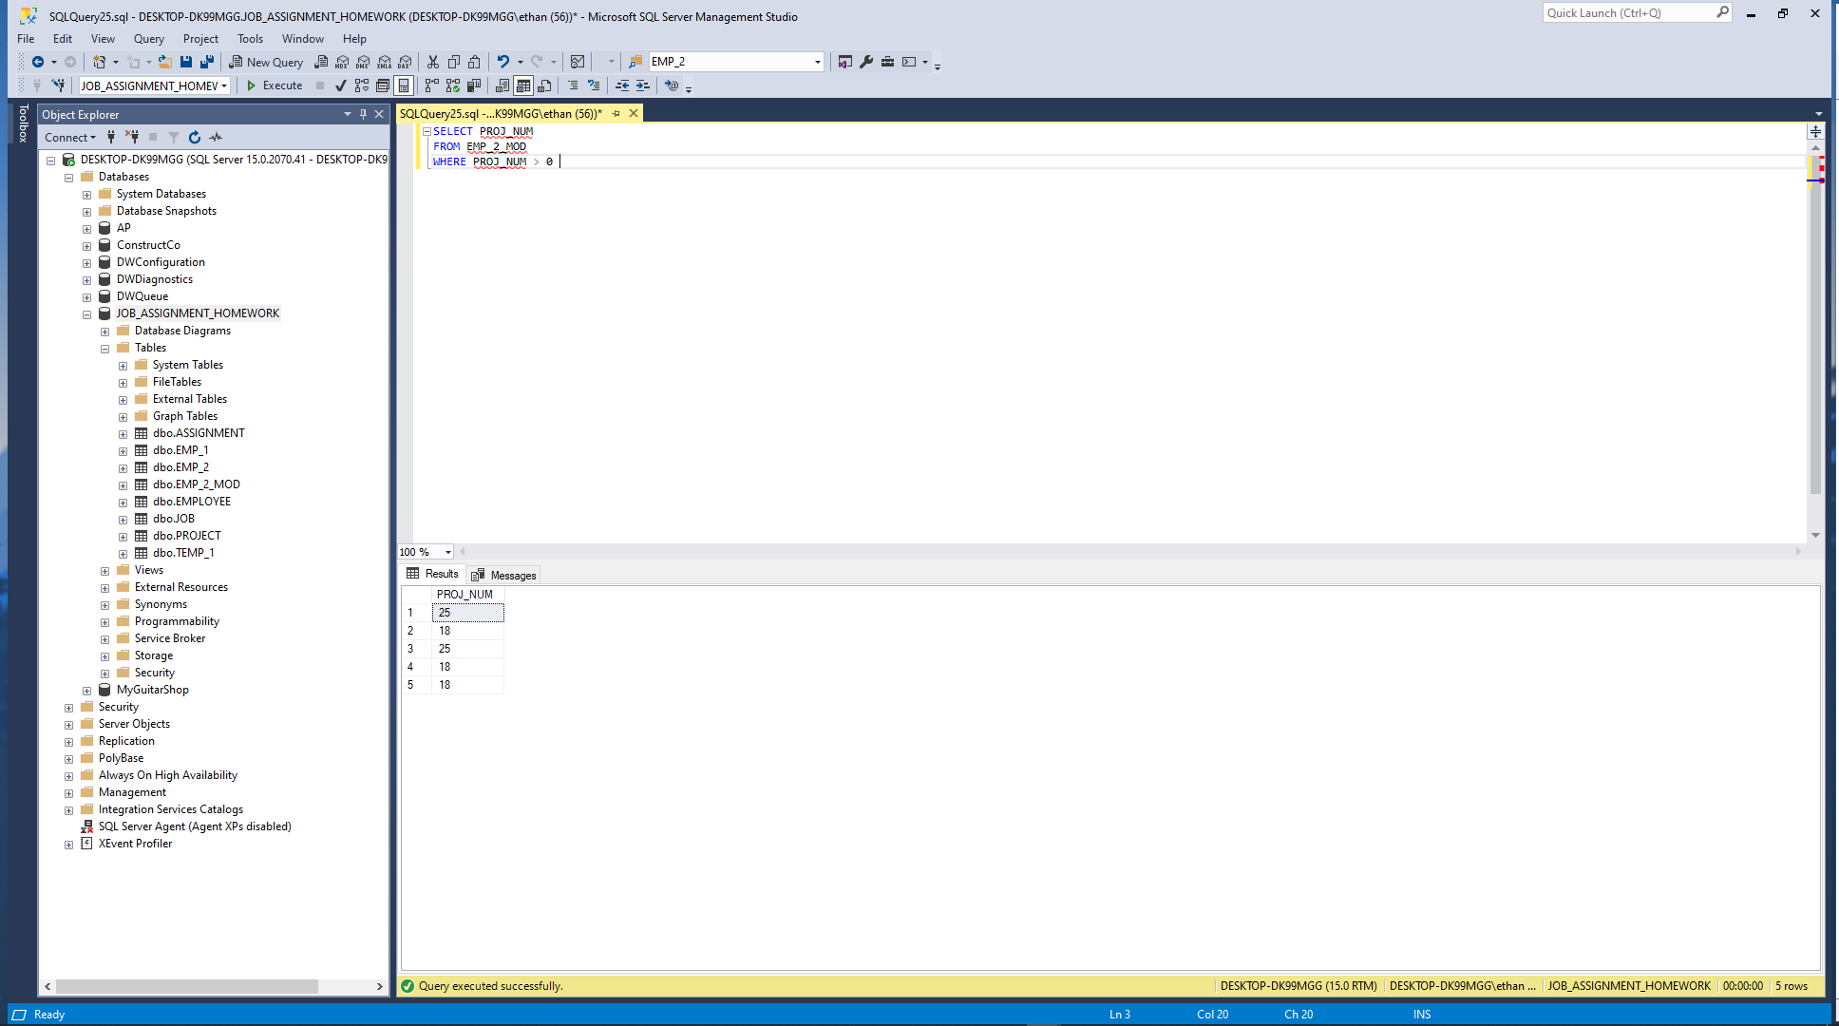

21. They are already calculated ??? The question asks to calculate but there already there

When you are finished zip this Word document with your answers AND your script files and then upload the zip file to the designated link in Canvas.